Canon David Shaw
The Rectory St Clement’s Church Office,
Rue du Presbytère La Grande Route de Saint Clément
St Clement JE2 6RB St Clement JE2 6QQ
Tel: 851992 Tel: 745260
Mobile: 07797 920316 E mail: stclementjersey@outlook.com

Rev Tracy Le C Bromley Tel: 857693 Rev Martin Dryden Tel: 874668

Facebook: St Clement Church Jersey Channel Islands – watch 10.30am service live and recorded
Web site: www.stclementschurch.org.je

Treasurers and church bank account details:

St Clement: Tricia Barry triciabarry@hotmail.com Acc: St Clement Church 40-25-34 84087488
St Nicholas: Ian Bromley captainimb@aol.com Acc: St Nicholas Church 60-12-03 81510535

Please put a note in the ‘reference’ for online banking so treasurers know what the payment is for and from whom if that is important.

July 21st, 2021

Dear friends of St Clement and St Nicholas,

Jersey government slightly belatedly announced some rules which affect worship ( masks for congregations over 50 people) but we pre-empted them with safer ones so a maximum of 50 will be allowed indoors for St Clement weddings and funerals with masks and no singing until cases subside. We will cater for larger congregations via live streaming to the hall and the outdoor loudspeaker. Weather allowing our Sunday pattern of worship is:
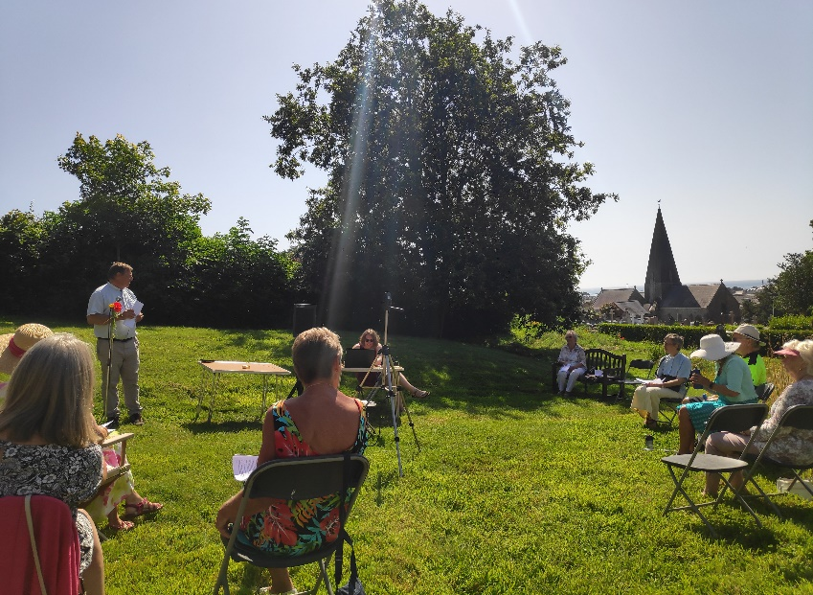
St Nicholas masks unless taking the service or reading and the distanced seating pattern with socializing outdoors. Spare masks available at the door.

St Clement moved back to the Meadow. A camera and internet connection moved as well this time so the outdoor services will be available to watch live on our Facebook page and in the week or so afterwards.
The flowers and birds were wonderful, do come along, chairs provided and deck chairs welcome.
The past week or so has been busy with news of bishops. Bishop Trevor formerly a suffragan in Winchester and then Bishop of Dover - which is really the bishop of Canterbury Diocese - has been taking care of the Channel Islands for the past few years even after his retirement from Dover. He is really retiring now and visited Jersey this week to say farewell. Bishop Tim of Winchester was the factor behind Jersey and Guernsey asking to change diocese. A few months ago he was asked to stand aside due to significant opposition to his style of leadership. At the end of last week it was announced he was taking early retirement.

In theory Jersey could rejoin Winchester but the legalities are too advanced and Salisbury is looking to be a very good home for the islands. There are already many links via the theological college there. The past seven years have been interesting and island churches have been much better at taking their giving seriously rather than assuming a diocese would prop up poor share payment. 100% of agreed share was paid in 2020 despite the huge effects of church closure on income as churches dipped into reserves. So there have been some benefits from the hiatus but it will be good to be part of a diocese again.
It will be a challenge to help Deanery churches and congregations feel part of a new diocese and we hope St Clement and St Nicholas can play a part in that.
We hope you are all keeping well,
David
Link to service recorded at St Nicholas on 18th July 2021: https://youtu.be/PvBVrnHyrH4

St Clement Church 10.30am Family Service July 25th 2021

The Lord our God, the Almighty reigns.
Let us rejoice and shout for joy, giving God the glory.

Glory to the Father and to the Son and to the Holy Spirit;
As it was in the beginning is now and shall be for ever. Amen.

CA 20 All over the world https://youtu.be/UR4tE1kh-mE

All over the world the Spirit is moving
All over the world, as the prophet said it would be
All over the world there’s a mighty revelation
Of the glory of the Lord
As the waters cover the sea.

All over his Church the Spirit is moving
All over his church as the prophet said it would be
All over his church there’s a mighty revelation
Of the glory of the Lord
As the waters cover the sea.

Right here in this place the Spirit is moving
Right here in this place as the prophet said it would be
Right here in this place, there’s a mighty revelation
Of the glory of the Lord
As the waters cover the sea.

All over the world the Spirit is moving
All over the world, as the prophet said it would be
All over the world there’s a mighty revelation
Of the glory of the Lord
As the waters cover the sea.
Of the glory of the Lord
As the waters cover the sea.

God in Christ has revealed his glory. Come let us worship.

From the rising of the sun to its setting. The Lord’s name is greatly to be praised.

Give him praise, you servants of the Lord. O praise the name of the Lord!

God shows his love for us in that, while we were still sinners, Christ died for us. Let us then show our love for him by confessing our sins in penitence and faith.

God our Father, we come to you in sorrow for our sins.

For turning away from you, and ignoring your will for our lives; Father, forgive us.
Save us and help us.

For behaving just as we wish, without thinking of you; Father, forgive us . Save us and help us.

For failing you by what we do, and think and say; Father, forgive us. Save us and help us.

For letting ourselves be drawn away from you by temptations in the world about us; Father, forgive us. Save us and help us.

For living as if we were ashamed to belong to your Son; Father, forgive us. Save us and help us.

May God who loved the world so much that he sent his Son to be our Saviour forgive us our sins and make us holy to serve him in the world through Jesus Christ our Lord. Amen

Let us declare our Faith in God
We believe in God the Father, from whom every family in heaven and on earth is named.

We believe in God the Son, who lives in our hearts through faith, and fills us with his love.

We believe in God the Holy Spirit, who strengthens us with power from on high.
We believe in one God; Father, Son and Holy Spirit. Amen

As the deer pants for the water https://youtu.be/peZudXt9faU

As the deer pants for the water
So my soul longs after you
You alone are my heart’s desire
And I long to worship you.

You alone are my strength, my shield
To you alone may my spirit yield
You alone are my heart’s desire
And I long to worship you.

I want you more than gold or silver
Only you can satisfy
You alone are the real joy-giver
And the apple of my eye.

You alone are my strength, my shield
To you alone may my spirit yield
You alone are my heart’s desire
And I long to worship you.

You’re my friend and you are my brother
Even though you are a King
I love you more than any other
So much more than anything

You alone are my strength, my shield
To you alone may my spirit yield
You alone are my heart’s desire
And I long to worship you.

The First reading is taken from 2 Kings, Chapter 4 beginning to read at the forty-second verse: ( 2 Kings 4 42-44)

⁴² A man came from Baal Shalishah, bringing the man of God twenty loaves of barley bread baked from the first ripe grain, along with some heads of new grain. “Give it to the people to eat,” Elisha said. ⁴³ “How can I set this before a hundred men?” his servant asked. But Elisha answered, “Give it to the people to eat. For this is what the Lord says: ‘They will eat and have some left over.’” ⁴⁴ Then he set it before them, and they ate and had some left over, according to the word of the Lord.
This is the word of the Lord. Thanks be to God

The Gospel Reading.

Hear the Gospel of our Lord Jesus Christ according to John.
Glory to you O Lord (John 6 1 -21 )
6 Some time after this, Jesus crossed to the far shore of the Sea of Galilee (that is, the Sea of Tiberias), ² and a great crowd of people followed him because they saw the signs he had performed by healing the sick. ³ Then Jesus went up on a mountainside and sat down with his disciples. ⁴ The Jewish Passover Festival was near. ⁵ When Jesus looked up and saw a great crowd coming toward him, he said to Philip, “Where shall we buy bread for these people to eat?” ⁶ He asked this only to test him, for he already had in mind what he was going to do.
⁷ Philip answered him, “It would take more than half a year’s wages^{[a]} to buy enough bread for each one to have a bite!”
⁸ Another of his disciples, Andrew, Simon Peter’s brother, spoke up, ⁹ “Here is a boy with five small barley loaves and two small fish, but how far will they go among so many?”
¹⁰ Jesus said, “Have the people sit down.” There was plenty of grass in that place, and they sat down (about five thousand men were there). ¹¹ Jesus then took the loaves, gave thanks, and distributed to those who were seated as much as they wanted. He did the same with the fish.
¹² When they had all had enough to eat, he said to his disciples, “Gather the pieces that are left over. Let nothing be wasted.” ¹³ So they gathered them and filled twelve baskets with the pieces of the five barley loaves left over by those who had eaten.
¹⁴ After the people saw the sign Jesus performed, they began to say, “Surely this is the Prophet who is to come into the world.” ¹⁵ Jesus, knowing that they intended to come and make him king by force, withdrew again to a mountain by himself.
¹⁶ When evening came, his disciples went down to the lake, ¹⁷ where they got into a boat and set off across the lake for Capernaum. By now it was dark, and Jesus had not yet joined them. ¹⁸ A strong wind was blowing and the waters grew rough. ¹⁹ When they had rowed about three or four miles,^{[b]} they saw Jesus approaching the boat, walking on the water; and they were frightened. ²⁰ But he said to them, “It is I; don’t be afraid.” ²¹ Then they were willing to take him into the boat, and immediately the boat reached the shore where they were heading.

This is the Gospel of the Lord. Praise to you O Christ

Reflection David: The Gospel reading had something for both our churches. St Nicholas can look out of their windows and imagine the stormy sea scene. There can hardly be a more stormy church to be in when the tide is up, the wind shakes the tiles and you can see and hear the sea just across the road.
For St Clement we read of Jesus in an area of grassy mountainside no doubt with lots of wild flowers, people sitting on the grass - so maybe picnic rugs rather than deck chairs would be appropriate this week. Sadly bread and fish and refreshments in general are discouraged for both churches at the moment.
The readings show Jesus challenging the expectations of even his closest followers. When things look impossible perhaps there is a solution in God’s mind we can’t imagine. The past year or so has been difficult for everybody. We can look back now and see how we were forced to change in ways we now value and will probably carry on for a long time.
Returning to normal whenever that may be should not be an excuse to get back into an old rut. This time of seemingly endless locking and unlocking need not be simply endured but like the Israelites in the wilderness it can be a time to try out new ways of being church.

Brother, Sister https://youtu.be/ttW9oQ-yiuU

Brother, sister, let me serve you
Let me be as Christ to you
Pray that I may have the grace to
Let you be my servant, too.

We are pilgrims on a journey
And companions on the road
We are here to help each other
Walk the mile and bear the load.

I will hold the Christlight for you
In the night time of your fear
I will hold my hand out to you
Speak the peace you long to hear.

I will weep when you are weeping
When you laugh, I’ll laugh with you
I will share your joy and sorrow
Till we’ve seen this journey through.

Brother, sister let me serve you
Let me be as Christ to you
Pray that I may have the grace to
Let you be my servant too.

The Collect for the Eighth Sunday after Trinity Almighty Lord and everlasting God, we beseech you to direct, sanctify and govern both our hearts and bodies in the ways of your laws
and the works of your commandments; that through your most mighty protection, both here and ever, we may be preserved in body and soul; through our Lord and Saviour Jesus Christ, who is alive and reigns with you, in the unity of the Holy Spirit, one God, now and for ever. Amen

Prayers ending: Lord in your mercy All: Hear our Prayer

Intercessions: In the World Council of Churches cycle of prayers we pray for Burundi, the Democratic Republic of Congo and Rwanda
Christians Together in Jersey are praying for the Portuguese Catholic community and the Sisters of Bethany
May the States of Jersey have wisdom and foresight as they endeavour to balance health, social and economic factors
Pray for all who work in the public sector (especially our hospitals and schools), that they may be properly valued and supported
May there be a greater sense of community and a willingness to think of others, especially the vulnerable and the less fortunate
Give thanks for emergency services everywhere, may they have access to the resources they need to deal with both natural and manmade disasters
Pray for peace on earth
Pray for the sick and the dying and those who worry about them and care for them
Give thanks for the departed and all who are grieving

Jesus taught us to call God our Father, so in faith and trust we pray:
The Lord’s Prayer: All: Our Father who art in heaven, hallowed be thy name, thy
kingdom come, thy will be done on earth as it is in heaven. Give us this day our daily bread and forgive us our trespasses as we forgive those who trespass against us and lead us not into temptation but deliver us from evil. For thine is the kingdom, the power and the glory forever and ever. Amen

Shine Jesus Shine https://youtu.be/J3iB30gCqAc

Lord, the light of your love is shining
In the midst of the darkness, shining
Jesus, light of the world, shine upon us
Set us free by the truth you now bring us
Shine on me, shine on me.

Shine, Jesus, Shine
Fill this land with the Father’s glory
Blaze, Spirit, blaze
St our hearts on fire.
Flow river flow
Flood the nation with grace and mercy
Send forth your word, Lord
And let there be light.

Lord, I come to your awesome presence
From the shadows into your radiance
By the blood I may enter your brightness
Search me, try me, consume all my darkness
Shine on me, shine on me. (Refrain)

As we gaze on your kingly brightness
So our faces display your likeness
Ever changing from glory to glory
Mirrored here may our lives tell your story
Shine on me, Shine on me.

Shine, Jesus, Shine
Fill this land with the Father’s glory
Blaze, Spirit, blaze
St our hearts on fire.
Flow river flow
Flood the nation with grace and mercy
Send forth your word, Lord
And let there be light.

Shine, Jesus, Shine
Fill this land with the Father’s glory
Blaze, Spirit, blaze
St our hearts on fire.
Flow river flow
Flood the nation with grace and mercy
Send forth your word, Lord
And let there be light.
let there be light.

The Grace May the Grace of our Lord Jesus Christ and the Love of God and the fellowship of the Holy Spirit, be with us all evermore. Amen

All our problems We send to the cross of Christ

All our difficulties We send to the cross of Christ

All the devils works We send to the cross of Christ

All our hopes We set on the risen Christ

The Blessing And the blessing of God almighty, the Father, the Son and the Holy Spirit be upon you and remain with you always. Amen

