Canon David Shaw

The Rectory St Clement’s Church Office,

Rue du Presbytère La Grande Route de Saint Clément

St Clement JE2 6RB St Clement JE2 6QQ

Tel: 851992 Tel: 745260

Mobile: 07797 920316 E mail: [stclementjersey@outlook.com](mailto:stclementjersey@outlook.com)

Rev Tracy Le C Bromley Tel: 857693 Rev Martin Dryden Tel: 874668

**Facebook: St Clement Church Jersey Channel Islands – watch 10.30am service live and recorded**

Web site: [www.stclementschurch.org.je](http://www.stclementschurch.org.je)

Treasurers and church bank account details:

St Clement: Tricia Barry [triciabarry@hotmail.com](mailto:triciabarry@hotmail.com) Acc: St Clement Church 40-25-34 84087488

St Nicholas: Ian Bromley [captainimb@aol.com](mailto:captainimb@aol.com) Acc: St Nicholas Church 60-12-03 81510535

***Please put a note in the ‘reference’ for online banking so treasurers know what the payment is for and from whom if that is important.***

**June 23rd, 2021**

**Dear friends of St Clement and St Nicholas,**

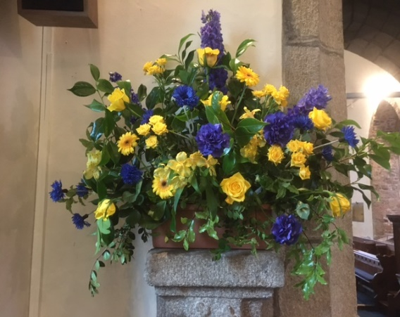

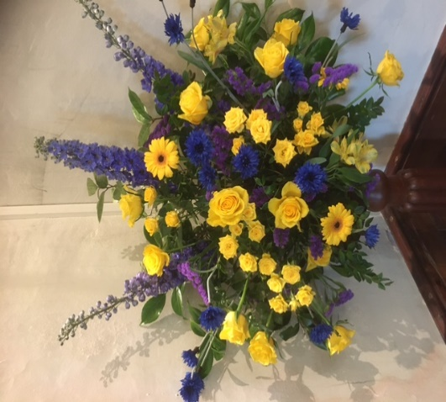A very big thank you to everyone who helped with Len’s funeral. Limited by restrictions around 260 attended - the biggest parish gathering for a year or more with track and trace complications added to by heavy rain.

From a church point of view it went very smoothly - the church had been expertly cleaned, flowers in parish colours looked wonderful, the family appreciated the music and people sang enthusiastically - for many the first time in over a year.

Technology enabled us to host a good number watching in the Caldwell Hall and many at home live and afterwards. Len’s importance to the island as well as his parish was underlined by the most comprehensive attendance by island and department leaders the church has perhaps ever hosted. Les Norman and Paul Routier gave excellent eulogies - well worth listening to if you tune into our Facebook page. Thank you again for all the church volunteers who really helped make a difference.

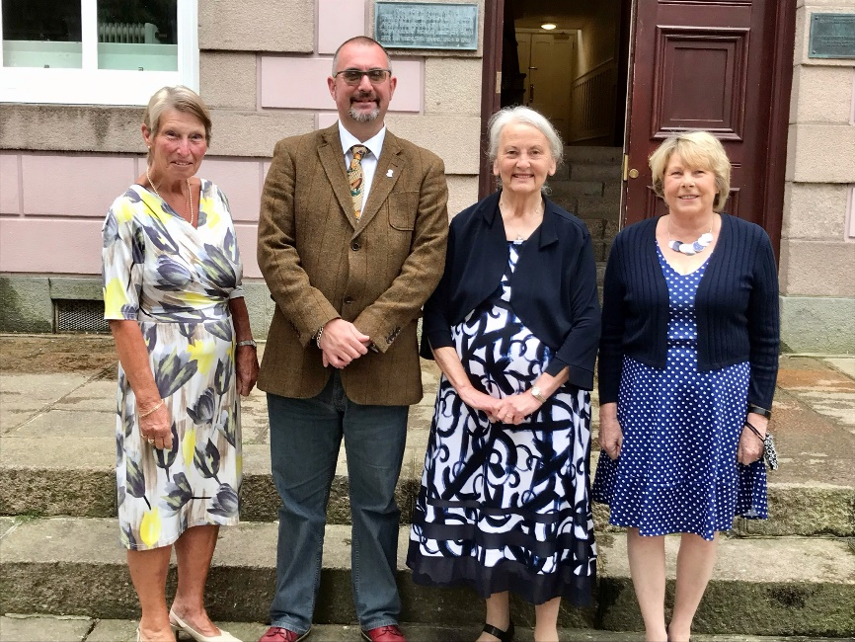

On Saturday after an absence last year the Ecclesiastical Court met in the Royal Court for the swearing in of church wardens and almoners. To comply with restrictions just three parishes at a time appeared before a restricted group of clergy minus the Dean who had been caught by track and trace from a flight the day before. I am just hoping nobody at the funeral tests positive or all the clergy and the organ will be silent on Sunday.

*Pictured Left to Right*

Carole Martin – Almoner

Tim Tindall – Church Warden

Evelyn Tucker – Church Warden

Eileen Algate – Almoner

Last Sunday saw the return of the church choir who were in excellent voice.  
  
Our parish awaits a possible election on 28th July with the swearing in on the 30th. In the meantime the Branchage still goes ahead this Friday afternoon so make sure everything is tidy.

There has been limited response to my request for feedback on what you would like to keep as life returns to normality- e mail of the service is welcomed by a few who have expressed an opinion,so that will carry on. Physical letters are clearly welcomed by one or two - we are happy to continue producing them but will need to check if all 25 per week are being read or if people can receive e mail instead. Please don’t be polite and not tell us they go in the bin ! Do say  if you don’t read it or would be happy to have it e mailed and save us some stamps .

Nobody so far has said they  use the internet hymn link so we will phase that out unless we hear positive requests by mid July. Facebook Live has some positive requests , we need feedback for the 9am St Nicholas.   
A few people are still expressing surprise that church is almost back to normal - so please just return as you did before. There are no limits on numbers. The only changes are we are a little more spaced around St Nicholas and generally every other pew in St Clement. Hymn singing is without masks - which most do not wear but people are welcome to carry on wearing.

Communion  is just the wafers and no wine. Coffee at St Nicholas and hopefully soon at St Clement. It would be really good to see anyone who has been keeping safe this last year.  If in the meantime your circumstances have changed and a home visit with or without communion would be appreciated please let us know.   
  
We hope you are keeping well

**St Clement Church 10.30am Family Service June 27th**

The Lord our God, the Almighty reigns.

**Let us rejoice and shout for joy, giving God the glory.**

Glory to the Father and to the Son and to the Holy Spirit;

**As it was in the beginning is now and shall be for ever. Amen.**

**Colours of Day** CA108 <https://youtu.be/_bZPRHIyVBA>

**Colours of Day dawn into the mind**

**The sun has come up, the night is behind**

**Go down in the city, into the street**

**And lets give the message**

**To the people we meet**

***So light up the fire and let the flame burn***

***Open the door, let Jesus return***

***Take seeds of his Spirit, let the fruit grow***

***Tell the people of Jesus, let his love show***

**Go through the park, on into the town**

**The sun still shines on; it never goes down**

**The light of the world is risen again**

**The people of darkness**

**Are needing our friend**

***So light up the fire and let the flame burn***

***Open the door, let Jesus return***

***Take seeds of his Spirit, let the fruit grow***

***Tell the people of Jesus, let his love show***

**Open your eyes, look into the sky**

**The darkness has come, the sun came to die**

**The evening draws on, the sun disappears**

**But Jesus is living**

**And his Spirit is near**

***So light up the fire and let the flame burn***

***Open the door, let Jesus return***

***Take seeds of his Spirit, let the fruit grow***

***Tell the people of Jesus, let his love show***

God in Christ has revealed his glory. **Come let us worship.**

From the rising of the sun to its setting. **The Lord’s name is greatly to be praised.**

Give him praise, you servants of the Lord**. O praise the name of the Lord!**

God shows his love for us in that, while we were still sinners, Christ died for us. Let us then show our love for him by confessing our sins in penitence and faith.

God our Father, we come to you in sorrow for our sins.

For turning away from you, and ignoring your will for our lives; Father, forgive us.

**Save us and help us.**

For behaving just as we wish, without thinking of you; Father, forgive us . **Save us and help us.**

For failing you by what we do, and think and say**;** Father, forgive us. **Save us and help us.**

For letting ourselves be drawn away from you by temptations in the world about us; Father, forgive us. **Save us and help us.**

For living as if we were ashamed to belong to your Son; Father, forgive us. **Save us and help us.**

May God who loved the world so much that he sent his Son to be our Saviour forgive us our sins and make us holy to serve him in the world through Jesus Christ our Lord*.* **Amen**

Let us declare our Faith in God

**We believe in God the Father, from whom every family in heaven and on earth is named.**

**We believe in God the Son, who lives in our hearts through faith, and fills us with his love.**

**We believe in God the Holy Spirit, who strengthens us with power from on high.**

**We believe in one God; Father, Son and Holy Spirit. Amen**

**Father, we adore you** CA166 <https://youtu.be/9bdid2HFk0c>

**Father, we adore you**

**Lay our lives before you**

**How we love you!**

**Jesus, we adore you**

**Lay our lives before you**

**How we love you!**

**Spirit, we adore you**

**Lay our lives before you**

**How we love you!**

**The First reading is taken from Psalm 30, beginning to read at the first verse**

**(Psalm 30 1 – 12)**

**1**I will exalt you, Lord, for you lifted me out of the depths and did not let my enemies gloat over me. **2**Lord my God, I called to you for help, and you healed me. **3**You, Lord, brought me up from the realm of the dead; you spared me from going down to the pit. **4**Sing the praises of the Lord, you his faithful people; praise his holy name.**5**For his anger lasts only a moment, but his favour lasts a lifetime; weeping may stay for the night, but rejoicing comes in the morning.

**6**When I felt secure, I said, “I will never be shaken.” **7**Lord, when you favoured me, you made my royal mountain[[c](https://www.biblegateway.com/passage/?search=Psalm+30&version=NIV#fen-NIV-14327c)] stand firm; but when you hid your face, I was dismayed.**8**To you, Lord, I called; to the Lord I cried for mercy:**9**“What is gained if I am silenced, if I go down to the pit?  
Will the dust praise you?  Will it proclaim your faithfulness?**10**Hear, Lord, and be merciful to me;  
Lord, be my help.”**11**You turned my wailing into dancing; you removed my sackcloth and clothed me with joy,**12**that my heart may sing your praises and not be silent.   Lord my God, I will praise you forever.

This is the word of the Lord. **Thanks be to God**

**The Gospel Reading.**

**Hear the Gospel of our Lord Jesus Christ according to Mark**

**Glory to you O Lord (Mark 5 21-43)**

**21**When Jesus had again crossed over by boat to the other side of the lake, a large crowd gathered around him while he was by the lake. **22**Then one of the synagogue leaders, named Jairus, came, and when he saw Jesus, he fell at his feet. **23**He pleaded earnestly with him, “My little daughter is dying. Please come and put your hands on her so that she will be healed and live.” **24**So Jesus went with him.

A large crowd followed and pressed around him. **25**And a woman was there who had been subject to bleeding for twelve years. **26**She had suffered a great deal under the care of many doctors and had spent all she had, yet instead of getting better she grew worse. **27**When she heard about Jesus, she came up behind him in the crowd and touched his cloak, **28**because she thought, “If I just touch his clothes, I will be healed.” **29**Immediately her bleeding stopped and she felt in her body that she was freed from her suffering.

**30**At once Jesus realized that power had gone out from him. He turned around in the crowd and asked, “Who touched my clothes?”

**31**“You see the people crowding against you,” his disciples answered, “and yet you can ask, ‘Who touched me?’ ”

**32**But Jesus kept looking around to see who had done it. **33**Then the woman, knowing what had happened to her, came and fell at his feet and, trembling with fear, told him the whole truth. **34**He said to her, “Daughter, your faith has healed you. Go in peace and be freed from your suffering.”

**35**While Jesus was still speaking, some people came from the house of Jairus, the synagogue leader. “Your daughter is dead,” they said. “Why bother the teacher anymore?”

**36**Overhearing[[c](https://www.biblegateway.com/passage/?search=Mark+5&version=NIV#fen-NIV-24401c)] what they said, Jesus told him, “Don’t be afraid; just believe.”

**37**He did not let anyone follow him except Peter, James and John the brother of James. **38**When they came to the home of the synagogue leader, Jesus saw a commotion, with people crying and wailing loudly. **39**He went in and said to them, “Why all this commotion and wailing? The child is not dead but asleep.” **40**But they laughed at him.

After he put them all out, he took the child’s father and mother and the disciples who were with him, and went in where the child was. **41**He took her by the hand and said to her, *“Talitha koum!”* (which means “Little girl, I say to you, get up!”). **42**Immediately the girl stood up and began to walk around (she was twelve years old). At this they were completely astonished. **43**He gave strict orders not to let anyone know about this, and told them to give her something to eat.

This is the Gospel of the Lord.  **Praise to you O Christ**

**Reflection David:**  Today’s Gospel miracles come in a two chapter section about the authority of Jesus. We have the calming of the storm showing power over nature; the Garasene man and the swine - power over demons and the reading for this Sunday showing his power over sickness and death. Jesus also challenges who is , in their terms, clean or unclean . Nobody would have wanted to touch the woman as blood was seen as unclean - one of the reasons put forward for the priests and Levites avoiding the injured man ignored until the Samaritan came along. Society has put at arms length all sorts of people over the years. Leprosy sufferers until relatively recently in Europe and still ostracized in parts of the World. today. People who look or behave ‘differently from us’ sums up a whole list of isms and phobias. Jesus challenges people to be willing to stand out from the crowd by putting more store on loving and accepting than the fear of being seen as strange or in the words of his time becoming ‘unclean’ by association. Who are we tempted to pass by today ?

**Take my life, and let it be** CA625 <https://youtu.be/sss-g50Dw1Q>

**Take my life, and let it be**

**Consecrated, Lord, to thee**

**Take my moments and my days**

**Let them flow in ceaseless praise.**

**Take my hands, and let them move**

**At the impulse of thy love**

**Take my feet, and let them be**

**Swift and beautiful for thee.**

**Take my voice, and let me sing**

**Always, only for my king**

**Take my lips, and let them be**

**Filled with messages from thee.**

**Take my silver and my gold**

**Not a mite would I withhold**

**Take my intellect, and use**

**Ev’ry pow’r as thou shalt choose.**

**Take my will, and make it thine**

**It shall be no longer mine**

**Take my heart, it is thine own**

**It shall be thy royal throne.**

**Take my love, my Lord, I pour**

**At thy feet its treasure-store**

**Take myself, and I will be**

**Ever, only, all for thee.**

**The Collect for the Fourth Sunday after Trinity:**  O God, the protector of all who trust in you, without whom nothing is strong, nothing is holy: increase and multiply upon us your mercy; that with you as our ruler and guide we may so pass through things temporal that we lose not our hold on things eternal; grant this, heavenly Father, for our Lord Jesus Christ’s sake, who is alive and reigns with you,in the unity of the Holy Spirit, one God, now and for ever.

***Music before Prayers* Amazing Grace** *(Flute solo)* <https://youtu.be/vV8ACSGFZOA>

Prayers ending: Lord in your mercy **All: Hear our Prayer**

**Intercessions:** World Council of Churches: please pray for Kenya and Tanzania

Christians Together in Jersey: prayers for St Peter’s Parish Church and their Rector Michael Phillips

Pray that the Church may live and grown in faith, hope and love

Pray for all who are in positions of power, that they may exercise it wisely, with justice and compassion

Let us thank God for our friends, wherever they may be in the world

May we be persistent in prayer and more faithful in Bible reading

Pray for renewed efforts to guard against coronavirus infection

Remember for all who have died in the recent past, and pray for their friends and family, that they may be comforted

Jesus taught us to call God our Father, so in faith and trust we pray:

**The Lord’s Prayer: All: Our Father who art in heaven, hallowed be thy name, thy**

**kingdom come, thy will be done on earth as it is in heaven. Give us this day our daily bread** **and forgive us our trespasses** **as we forgive those who trespass against us and lead us not into temptation but deliver us from evil. For thine is the kingdom, the power and the glory forever and ever. Amen**

**Bind us together, Lord** CA72 <https://youtu.be/wRwfTS_Ne0o>

***Bind us together, Lord***

***Bind us together with cords***

***That cannot be broken***

***Bind us together, Lord***

***Bind us together, Lord***

***Bind us together, in love***

***There is only one God***

***There is only one King***

***There is only one Body***

***That is why we sing (refrain)***

***Fit for the glory of God***

***Purchased by his precious Blood***

***Born with the right to be free***

***Jesus the vict’ry has won. (refrain)***

***We are the fam’ly of God***

***We are his promise divine***

***We are his chosen desire***

***We are the glorious new wine***

***Bind us together, Lord***

***Bind us together with cords***

***That cannot be broken***

***Bind us together, Lord***

***Bind us together, Lord***

***Bind us together, in love***

**The Grace May the Grace of our Lord Jesus Christ and the Love of God and the fellowship of the Holy Spirit, be with us all evermore**. **Amen**

All our problems **We send to the cross of Christ**

All our difficulties **We send to the cross of Christ**

All the devils works **We send to the cross of Christ**

All our hopes **We set on the risen Christ**

**The Blessing And the blessing of God almighty, the Father, the Son and the Holy Spirit be upon you and remain with you always. Amen**

*Closing Music* **Flourish - Paul Sharman** <https://youtu.be/JYEH3dwZRvg>