Canon David Shaw
The Rectory St Clement’s Church Office,
Rue du Presbytère La Grande Route de Saint Clément
St Clement JE2 6RB St Clement JE2 6QQ
Tel: 851992 Tel: 745260
Mobile: 07797 920316 E mail: stclementjersey@outlook.com

Rev Tracy Le C Bromley Tel: 857693 Rev Martin Dryden Tel: 874668

Facebook: St Clement Church Jersey Channel Islands
watch 10.30am service live and recorded Web site: www.stclementschurch.org.je

Treasurers and church bank account details:
St Clement: Tricia Barry triciabarry@hotmail.com Acc: St Clement Church 40-25-34 84087488
St Nicholas: Ian Bromley captainimb@aol.com Acc: St Nicholas Church 60-12-03 81510535

6th April 2021
Dear friends of St Clement and St Nicholas
Christ is risen! He is risen indeed, Alleluia!
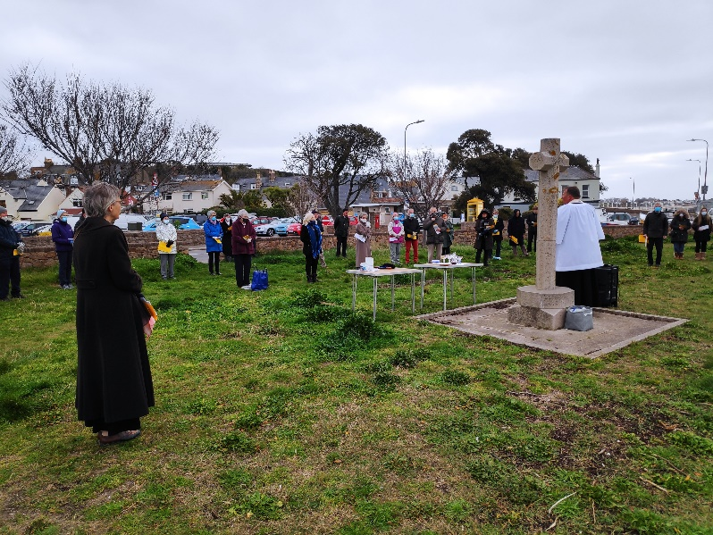
I know that many of you felt that Holy
Week and Easter had a special significance this year as it was almost normal! We began with our Easter Sunrise service at Le Hocq Common,
even if we were spaced two metres
apart, had to sing through masks and
were not able to celebrate with freshly-
baked bread from Samarès Manor.

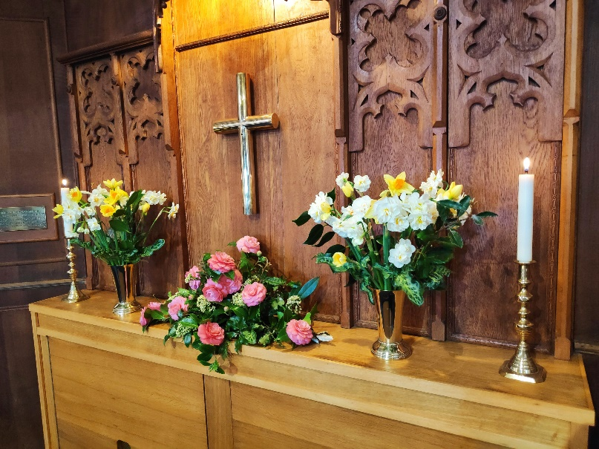
At St Nicholas, the congregation enjoyed a beautifully decorated church (courtesy of Philippa Romeril) and joyful Easter hymns streamed from the Internet, and we began the 10h30 service at the Parish Church by decorating a wooden cross with daffodils, a wonderful symbol of new life springing out of hatred and death. You
can see a picture of it at the end of this
letter.

As things gradually return to normal, and before we all forget the extraordinary events of the past 12 months, the Rector (before taking a very well-earned break) asked Graham Caldbeck, our Director of Music, to reflect on life without singing in church.

Here is what he said:
How shall we sing the Lord's song: in a strange land? (Psalm 137)

For over a year now Government regulations have not permitted congregational hymn singing in church. Most people have missed this a great deal. From the outset of this musically mute time, St. Clement decided to try to keep hymn singing alive by providing YouTube links to performances of the hymns selected by me as Director of Music and Tracy as music & liturgy advisor. These have been broadcast via loudspeakers, both outside, for the ‘fair weather’ services held in the Meadow, and inside, during the seasons of inclement weather. These links have also been included in the online service sheets e-mailed to members of the congregation who have been shielding or who have been unwell. In addition to these hymn links, links have been included to musical extracts used before the Prayers, during Communion and as closing music.

Sourcing YouTube performances that are musically inspiring sometimes provides a challenge and occasionally it has been impossible to find the chosen hymn. Another hurdle is trying to match the sung words with the text included in the service sheet – we have been reasonably successful in this...

Hymn singing at St. Clement is an important aspect of our worship and in recent years we have greatly expanded the variety of the hymns sung. At the last count, excluding seasonal hymns we have performed some 345 different hymns since September 2013. Hearing our weekly hymns will have done much to keep many of these current and in our minds.

‘Every cloud has a silver lining’, as they say (or sing?) and some members of the congregation have mentioned to me that, despite missing the singing, they have valued the opportunity of following the words of the hymns more reflectively and perhaps more closely.

Musically, congregations have felt themselves to be exiled, unable to sing the Lord’s song in a very strange masked land. Soon we shall be able to have twenty singers singing hymns to forty (rather more encouraging than nought to nought…). We’re moving in the right direction and I hope soon will be better able to follow St. Paul’s advice:

Speaking to yourselves in psalms and hymns and spiritual songs, singing and making melody in your heart to the Lord; Ephesians 5 v.19

Graham Caldbeck
Director of Music
+++

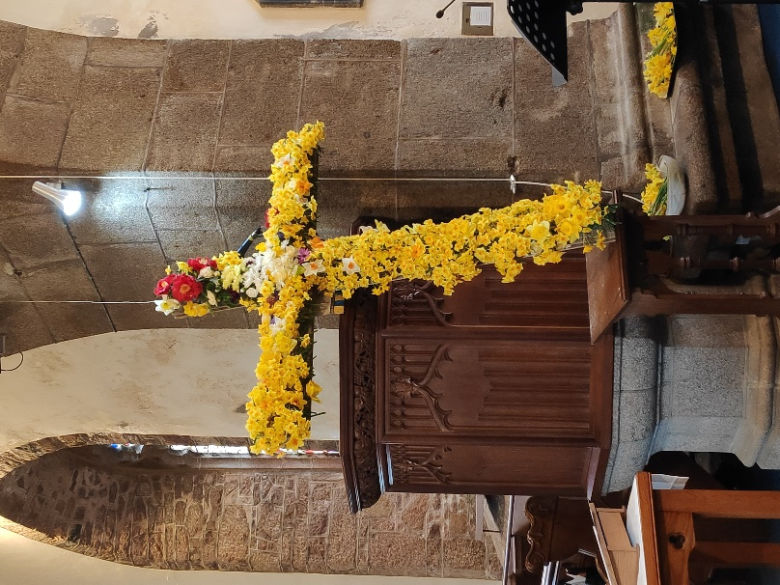
Thank you, Graham, we so appreciate the music
that you bring to our worship. It is only when
something is taken away that you realise what
you have lost!

Last Sunday was Easter Day, but Easter is a
season, lasting 40 days, until the Day of
Pentecost, which this year falls on 23rd May.
During this time, we will be reflecting on what
the resurrection of Jesus means for us and for
the world. What better time to do so as the
natural world around us awakens from winter
and blossoms into spring, but also as new life
begins to emerge after a pandemic that has
brought death and destruction. Christ has risen
indeed. Happy Easter!

Martin Dryden

THE PARISH CHURCH OF ST CLEMENT MORNING WORSHIP IN EASTERTIDE

Love’s redeeming work is done CA433 https://youtu.be/LEbBB8DoBIE

Love’s redeeming work is done
Fought the fight, the battle won
Lo, our Sun’s eclipse is o’er
Lo, he sets in blood no more.

Vain the stone, the watch, the seal
Christ has burst the gates of hell
Death in vain forbids his rise
Christ has opened paradise.

Lives again our glorious King
Where, O death, is now thy sting?
Dying once, he all doth save
Where thy victory, O grave?

Soar, we now where Christ has led
Foll’wing our exalted Head
Made like him, like him we rise
Ours the cross, the grave, the skies.

Hal the Lord of earth an heav’n
Praise to thee by both be giv’n
Thee we greet triumphant now
Hail, the Resurrection thou!

Christ our passover lamb has been sacrificed for us. Let us therefore rejoice by putting away all malice and evil and confessing our sins with a sincere and true heart. 1 Corinthians 5.7,8

We to sit or kneel to confess our sins

Like Mary at the empty tomb, we fail to grasp the wonder of your presence.
Lord, have mercy Lord, have mercy.

Like the disciples behind locked doors, we are afraid to be seen as your followers.
Christ, have mercy. Christ, have mercy.

Like Thomas in the upper room, we are slow to believe.
Lord, have mercy. Lord, have mercy

May the God of love and power forgive you and free you from your sins,
heal and strengthen you by his Spirit, and raise you to new life in Christ our Lord. Amen.

We stand

Blessed is the Lord, for he has heard the voice of our prayer;
therefore shall our hearts dance for joy and in our song we will praise our God.

Blessed are you, Lord our God, Creator and Redeemer of all; to you be glory and praise for ever.
From the waters of chaos you drew forth the world and in your great love fashioned us in your image.
Now, through the deep waters of death, you have brought your people to new birth by raising your Son to life in triumph. May Christ your light ever dawn in our hearts as we offer you our sacrifice of thanks and praise. Blessed be God, Father, Son and Holy Spirit: Blessed be God for ever.

Now the green blade riseth CA475 https://youtu.be/27p98aLPZPI

Now the green blade riseth
From the buried grain
Wheat that in the dark earth
Many days has lain
Love lives again
That with the dead has been
Love is come again
Like wheat that springeth green.

In the grave they laid him
Love by hatred slain
Thinking that never
He would wake again
Laid in the earth
Like grain that sleeps unseen
Love is come agaih
Like wheat that springeth green.

Forth he came at Easter
Like the risen grain
He that for three days
In the grave had lain
Quick from the dead
My risen Lord is seen
Love is come again
Like wheat that springeth green.

When our hearts are wintry
Grieving or in pain
Thy touch can call us
Back to life again
Fields of our hearts
That dead and bare have been
Love is come again
Like wheat that springeth green.

The Easter Anthems We stand

Christ our Passover has been sacrificed for us: so let us celebrate the feast, not with the old leaven of corruption and wickedness: but with the unleavened bread of sincerity and truth.
1 Corinthians 5.7b, 8 3

Christ once raised from the dead dies no more: death has no more dominion over him. In dying he died to sin once for all: in living he lives to God. See yourselves therefore as dead to sin: and alive to God in Jesus Christ our Lord. Romans 6.9-11 6

Christ has been raised from the dead: the first fruits of those who sleep. For as by man came death: by man has come also the resurrection of the dead; for as in Adam all die: even so in Christ shall all be made alive. 1 Corinthians 15.20-22

Glory to the Father and to the Son and to the Holy Spirit;
as it was in the beginning is now and shall be for ever. Amen.

Readings

The First Reading is taken from Acts, Chapter 4,
beginning to read at the thirty-second verse.

³² All the believers were one in heart and mind. No one claimed that any of their possessions was their own, but they shared everything they had. ³³ With great power the apostles continued to testify to the resurrection of the Lord Jesus. And God’s grace was so powerfully at work in them all ³⁴ that there were no needy persons among them. For from time to time those who owned land or houses sold them, brought the money from the sales ³⁵ and put it at the apostles’ feet, and it was distributed to anyone who had need.
(Acts 4: 32-35)
At the end the reader says This is the word of the Lord. Thanks be to God.

Jesus lives! CA354 https://youtu.be/ZCz-HYIxmvE

Jesus lives! Thy terrors now
Can no more, O death, appal us
Jesus lives! By this we know
Thou, O grave, canst not enthral us
Alleluia

Jesus lives! Henceforth is death
But the gate of life immortal
This shall calm our trembling breath
When we pass its gloomy portal
Alleluia

Jesus lives! For us he died
Then, alone to Jesus living
Pure in heart may we abide
Glory to our Saviour giving
Alleluia

Jesus lives! Our hearts know well
Naught from us his love shall sever
Life nor death nor pow’rs of hell
Tear us from his keeping ever.
Alleluia

Jesus lives! To him the throne
Over all the world is given
May we go where he is gone
Rest and reign with him in heaven
Alleluia

When the Gospel is announced the reader says
Hear the Gospel of our Lord Jesus Christ according to John Glory to you, O Lord.

¹⁹ On the evening of that first day of the week, when the disciples were together, with the doors locked for fear of the Jewish leaders, Jesus came and stood among them and said, “Peace be with you!” ²⁰ After he said this, he showed them his hands and side. The disciples were overjoyed when they saw the Lord. ²¹ Again Jesus said, “Peace be with you! As the Father has sent me, I am sending you.” ²² And with that he breathed on them and said, “Receive the Holy Spirit. ²³ If you forgive anyone’s sins, their sins are forgiven; if you do not forgive them, they are not forgiven.”

²⁴ Now Thomas (also known as Didymus^{[a]}), one of the Twelve, was not with the disciples when Jesus came. ²⁵ So the other disciples told him, “We have seen the Lord!”
But he said to them, “Unless I see the nail marks in his hands and put my finger where the nails were, and put my hand into his side, I will not believe.”

²⁶ A week later his disciples were in the house again, and Thomas was with them. Though the doors were locked, Jesus came and stood among them and said, “Peace be with you!” ²⁷ Then he said to Thomas, “Put your finger here; see my hands. Reach out your hand and put it into my side. Stop doubting and believe.” ²⁸ Thomas said to him, “My Lord and my God!” ²⁹ Then Jesus told him, “Because you have seen me, you have believed; blessed are those who have not seen and yet have believed.”

³⁰ Jesus performed many other signs in the presence of his disciples, which are not recorded in this book. ³¹ But these are written that you may believe^{[b]} that Jesus is the Messiah, the Son of God, and that by believing you may have life in his name.
(John 20: 19-31)

At the end the reader says This is the Gospel of the Lord Praise to you, O Christ.

Reflection (Martin)

Today is traditionally known as Low Sunday but our readings suggest that it is anything but low! In the first reading, Luke (who wrote the Book of Acts) describes one of the effects of the Holy Spirit coming upon the disciples at Pentecost. Two thousand years later, the thought of sharing everything together is still shocking. In fact, it is probably more shocking today in our highly individualistic and materialistic society than it was then. The gospel reading, which is Pentecost according to St John, may at first seem less dramatic than Luke’s account, but according to John, locked doors couldn’t keep Jesus out of the lives of those he had chosen. That is pretty dramatic.

Some Christians describe coming to faith as a conversion. It is a good word. Conversion is when the penny drops, like when you first learned to do long division. You may still make mistakes, but you never forget! When you see something in a new light, it changes your life. Conversion prompted those first disciples to decide to share everything they had. Conversion caused Thomas to exclaim: “my Lord and my God” when Jesus invited him to put his fingers in his side, and (according to tradition) to take the gospel to India and to die for his faith.

Have you been converted? How can you tell? There is a difference between ‘before’ and ‘after’, whether you describe the event in terms of a blazing fire (like Luke) or the gentle breath of Jesus (like John). ‘Before’ is when you know the Bible stories and you understand with your mind what faith is. ‘After’ is when you understand with your heart, you begin to live the gospel and it starts to become part of you. As we make our way through the season of Easter and journey towards Pentecost, let us pray for the Holy Spirit to help us love God with all our heart and to love our neighbour as ourselves, because these are by far the most reliable signs of conversion.

We stand to say the Creed
We believe in one God, the Father, the Almighty,
maker of heaven and earth, of all that is, seen and unseen.
We believe in one Lord, Jesus Christ, the only Son of God, eternally begotten of the Father,
God from God, Light from Light, true God from true God, begotten, not made,
of one Being with the Father; through him all things were made.
For us and for our salvation he came down from heaven,
was incarnate from the Holy Spirit and the Virgin Mary and was made man.
For our sake he was crucified under Pontius Pilate; he suffered death and was buried.
On the third day he rose again in accordance with the Scriptures;
he ascended into heaven and is seated at the right hand of the Father.
He will come again in glory to judge the living and the dead, and his kingdom will have no end.
We believe in the Holy Spirit, the Lord, the giver of life,
who proceeds from the Father and the Son,
who with the Father and the Son is worshipped and glorified,
who has spoken through the prophets.
We believe in one holy catholic and apostolic Church.
We acknowledge one baptism for the forgiveness of sins.
We look for the resurrection of the dead, and the life of the world to come. Amen.

Prayers of Intercession
We sit or kneel
Lord, in your mercy hear our prayer.

May we live as those who believe in the triumph of the Cross.
The World Council of Churches asks us to pray for the countries of Bulgaria, Hungary and Romania.
In the Christians Together in Jersey cycle of prayers, we pray for the congregation of St Mark’s Anglican Church in David Place and for all who are ministering there during the interregnum.
Pray for a resolution to the world’s many conflicts, that all may live in peace.
Pray for an equitable distribution of the coronavirus vaccines.
The peoples of South Africa have a word: Ubuntu, meaning “I am because you are.” Let us ask God to help us to love our neighbour as ourselves.
Let us pray for those we know who are sick in body, mind or spirit.
As Jesus gladdened the hearts of his friends when they saw him raised from the dead, may we seek to encourage all who are struggling with life.
Let us remember all who have died in the hope of the resurrection.

And at the end Merciful Father,
accept these prayers for the sake of your Son, our Saviour Jesus Christ. Amen.

The Collect for the Second Sunday of Easter: Almighty Father, you have given your only Son to die for our sins and to rise again for our justification: grant us so to put away the leaven of malice and wickedness that we may always serve you in pureness of living and truth; through the merits of your Son Jesus Christ our Lord, who is alive and reigns with you, in the unity of the Holy Spirit, one God, now and for ever. Amen

The Collect for Easter Day: Lord of all life and power, who through the mighty resurrection of your Son overcame the old order of sin and death to make all things new in him: grant that we, being dead to sin and alive to you in Jesus Christ, may reign with him in glory; to whom with you and the Holy Spirit be praise and honour, glory and might, now and in all eternity. Amen

The Lord’s Prayer
Gathering our prayers and praises into one, let us pray with confidence as our Saviour has taught us:
Our Father, who art in heaven, hallowed be thy name; thy kingdom come; thy will be done on earth as it is in heaven. Give us this day our daily bread. And forgive us our trespasses, as we forgive those who trespass against us. And lead us not into temptation; but deliver us from evil. For thine is the kingdom, the power, and the glory for ever and ever. Amen.

If Christ had not been raised from death A&M204 https://youtu.be/nRqeogaMgs4

If Christ had not been raised from death
Our faith would be in vain
Our preaching but a waste of breath
Our sin and guilt remain
But now the Lord is risen indeed
He rules in earth and heaven
His gospel meets a world of need
In Christ we are forgiven.

If Christ still lay within the tomb
Then death would be the end
And we should face our final doom
With neither guide nor friend
But now the Saviour is raised up
So when a Christian dies
We mourn, yet look to God in hope
In Christ the saints arise!

If Christ had not been truly raised
His church would live a lie
His name should nevermore be praised
His words deserve to die.
But now our great redeemer lives
Through him we are restored
His word endures, his church revives
In Christ our risen Lord.

The Blessing:
The God of peace, who brought again from the dead our Lord Jesus, that great shepherd of the sheep, through the blood of the eternal covenant, make you perfect in every good work to do his will,bworking in you that which is well-pleasing in his sight; and the blessing of God almighty, the Father, the Son, and the Holy Spirit, be among you and remain with you always. Amen.

We say the Grace together
The grace of our Lord Jesus Christ,
and the love of God,
and the fellowship of the Holy Spirit,
be with us all evermore. Amen.

Go in peace, to love and serve the Lord
Thanks be to God.

