Canon David Shaw
The Rectory St Clement’s Church Office,
Rue du Presbytère La Grande Route de Saint Clément
St Clement JE2 6RB St Clement JE2 6QQ
Tel: 851992 Tel: 745260
Mobile: 07797 920316 E mail: stclementjersey@outlook.com

Rev Tracy Le C Bromley Tel: 857693 Rev Martin Dryden Tel: 874668

Facebook: St Clement Church Jersey Channel Islands
Web site: www.stclementschurch.org.je

Treasurers and church bank account details:
St Clement: Tricia Barry triciabarry@hotmail.com Acc: St Clement Church 40-25-34 84087488
St Nicholas: Ian Bromley captainimb@aol.com Acc: St Nicholas Church 60-12-03 81510535

November 25th 2020

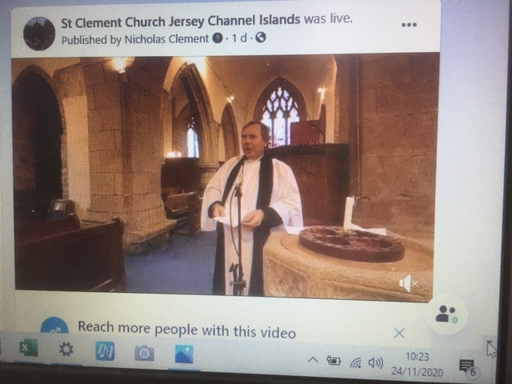
Dear friends of St Clement and St Nicholas,
Tracy and I breathed a sigh of relief at the end of last Sunday’s services. Thanks to Tim and Jenni sorting the Face book link, an excellent new camera and advice from Delta plus wifi, projector two laptops an i pad, outdoor speaker, lots of wire and fingers crossed we could hold a 10.30 service – simple !

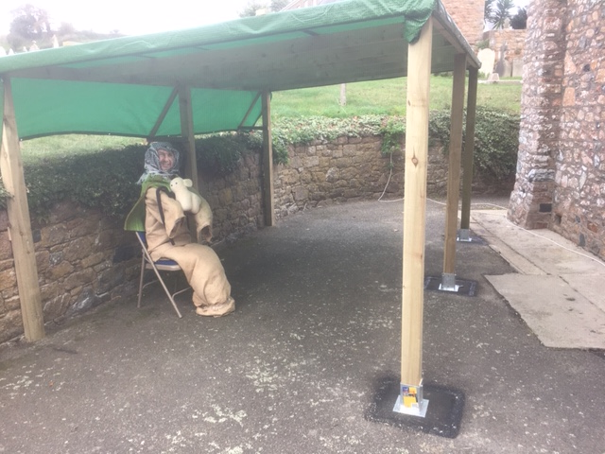
We can now keep within government limits on church attendance and stream the service live onto a large screen in the Caldwell Hall. An outdoor speaker and an incredibly solid shelter outside the main church door give an alternative very well ventilated space – sides to follow. Meanwhile the Face book link was streamed live to people’s homes and the 10.30 service video is still available to watch on the site. People at home can now watch the 10.30 live or later on and join in with the printed or emailed text. We are also looking to link the video directly into the church website and we can offer funerals and weddings the option of relatives and friends tuning in from afar.

If you are already a Face Book user just look up St Clement Church Jersey Channel Islands and move onto the next paragraph – if like me you have avoided it – it is very simple and the only personal information you need to supply is a phone number , we gave an imaginary name and made up a date of birth but they automatically reject your application until they can send you a code via a text to a mobile phone. You could lie in bed watching but we really would rather see you at church !

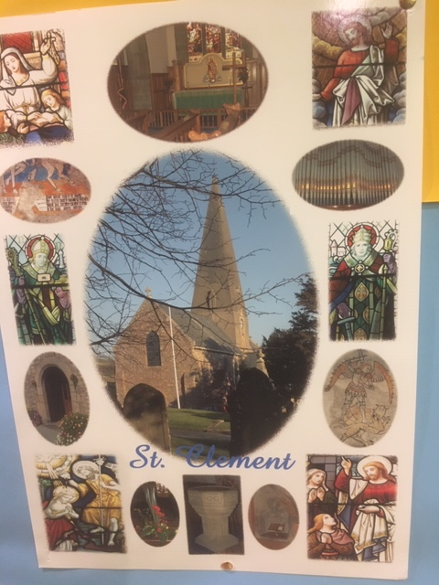
It was a St Clement’s Day service with a difference, no Scouts or wreath laying or Parish Lunch to follow but Evelyn put together a lovely display complete with anchor – part pictured left.

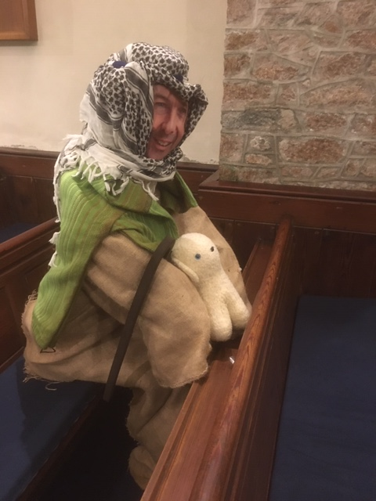
I much prefer the certainty of a staple gun and a drill to websites designed by teenagers with amazing eyesight. So I have been delighted with the response to my offer to turn old duvets into figures in the church. Our new congregation member – John Le F. Shepherd - consists of two sleeping bags, a couple of sacks an old pillow and some wood and he helped bulk out our restricted numbers - more will follow. All part of our aim to enable people to celebrate Christmas in church despite us being subject to some of the toughest worship restrictions in the British Isles. Plans for our Nativity Festival are progressing well. Old flock or feather pillows would be gratefully received – just leave on the Rectory doorstep or bring to church. They can be turned into heads ready for the “celebrity face” to be applied.

Thank you also to people offering to be on the list of helpers. More needed and a rota will evolve once we have confirmed the programme. The Nativity Festival will hopefully attract a lot of the people who visit us just once or twice a year. We are also thinking of holding a few “real” services which we can stream to homes. Subject to regulations there will be a limited number of spaces in the congregation for each service and we will offer these first of all via our church notices and regular mail out.

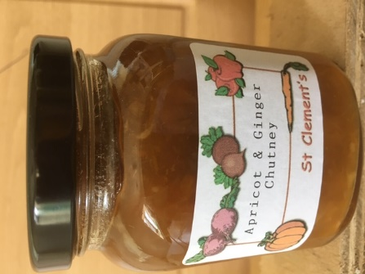
Do contact Martin Dryden if you haven’t picked up your Advent Calendar. The Gift Day letters are being given out in the churches and any left will be posted .

Finally – looking for ideas for Christmas presents ? Why not buy a dozen or two jars of Pam’s delicious home made chutneys – always a welcome gift and perfect for cold turkey and ham - ring 732710.

On behalf of all at St Clement and St Nicolas we hope you are keeping well.

David
THE PARISH CHURCH OF ST CLEMENT
MORNING WORSHIP IN ADVENT
November 29th, 2020
OPENING HYMN
Hills of the north, rejoice https://youtu.be/D-MKEYz-9-I

Hills of the north, rejoice
Echoing songs arise
Hail with united voice
Him who made earth and skies
He comes in righteousness and love
He brings salvation from above.

Isles of the southern seas
Sing to the list’ning earth
Carry on ev’ry breeze
Hope of a world’s new birth
In Christ shall all be made anew
His word is sure, his promise true.

Lands of the east, arise
He is your brightest morn,
Greet him with joyous eyes
Praise shall his path adorn
The God whom you have longed to know
In Christ draws near, and calls you now.

Shores of the utmost west,
Lands of the setting sun
Welcome the heav’nly guest
In whom the dawn has come
He brings a never-ending light
Who triumphed o’er our darkest night.

Shout, as you journey on
Songs be in ev’ry mouth
Lo, from the north they come
From east and west and south
In Jesus all shall find their rest
In him the longing earth be blest.

The grace of our Lord Jesus Christ, The love of God, and the fellowship of the Holy Spirit be with you. and also with you.
We have come together in the name of Christ to offer our praise and thanksgiving, to hear and receive God’s holy word, to pray for the needs of the world, and to seek the forgiveness of our sins, that by the power of the Holy Spirit we may give ourselves to the service of God.

We to sit or kneel to confess our sins

A voice cries out in the wilderness ‘Make straight the way of the Lord.’ So let us listen, and turn to the Lord in penitence and faith. cf John 1:23
Most merciful God, Father of our Lord Jesus Christ, we confess that we have sinned in thought, word and deed. We have not loved you with our whole heart. We have not loved our neighbours as ourselves. In your mercy forgive what we have been, help us to amend what we are, and direct what we shall be; that we may do justly, love mercy, and walk humbly with you, our God. Amen.

Almighty God, who forgives all who truly repent, have mercy upon you, pardon and deliver you from all your sins, confirm and strengthen you in all goodness, and keep you in life eternal; through Jesus Christ our Lord. Amen.

We stand Blessed is the Lord, for he has heard the voice of our prayer;
therefore shall our hearts dance for joy and in our song we will praise our God.
Blessed are you, Lord our God, Creator and Redeemer of all; to you be glory and praise for ever.
From the waters of chaos you drew forth the world and in your great love fashioned us in your image. Now, through the deep waters of death, you have brought your people to new birth by raising your Son to life in triumph. May Christ your light ever dawn in our hearts as we offer you our sacrifice of thanks and praise. Blessed be God, Father, Son and Holy Spirit: Blessed be God for ever.

Come, thou long-expected Jesus https://youtu.be/1IokFvkhYcc

Come, thou long-expected Jesus
Born to set thy people free
From our fears and sins release us
Let us find our rest in thee.

Israel’s strength and consolation
Hope of all the earth thou art
Dear desire of ev’ry nation
Joy of ev’ry longing heart.

Born thy people to deliver
Born an child and yet a King
Born to reign in us for ever
Now thy gracious kingdom bring.

By thine own eternal Spirit
Rule in all our hearts alone
By thine all sufficient merit
Raise us to thy glorious throne.

The night has passed, and the day lies open before us; let us pray with one heart and mind.

We keep silence We say the Old Testament Canticle

Blessed are you, God of Israel, for ever and ever, for yours is the greatness, the power, the glory, the splendour and the majesty. Everything in heaven and on earth is yours; yours is the kingdom, O Lord, and you are exalted as head over all. Riches and honour come from you and you rule over all. In your hand are power and might; yours it is to give power and strength to all. And now we give you thanks, our God, and praise your glorious name. For all things come from you, and of your own have we given you. Glory to the Father and to the Son and to the Holy Spirit; as it was in the beginning is now and shall be for ever. Amen.

The First reading is taken from Psalm 80, beginning to read at the first verse (Psalm 80 1-8 18-20)
Hear us, Shepherd of Israel, you who lead Joseph like a flock. You who sit enthroned between the cherubim, shine forth ² before Ephraim, Benjamin and Manasseh. Awaken your might; come and save us. ³ Restore us, O God; make your face shine on us, that we may be saved.
⁴ How long, Lord God Almighty, will your anger smoulder against the prayers of your people?
⁵ You have fed them with the bread of tears; you have made them drink tears by the bowlful.
⁶ You have made us an object of derision^{[b]} to our neighbours, and our enemies mock us.
⁷ Restore us, God Almighty; make your face shine on us, that we may be saved. You transplanted a vine from Egypt; you drove out the nations and planted it. Then we will not turn away from you;
revive us, and we will call on your name. ¹⁹ Restore us, Lord God Almighty; make your face shine on us, that we may be saved.

This is the word of the Lord. Thanks be to God.

The Gospel Canticle
O bless the God of Israel, who comes to set us free, who visits and redeems us and grants us liberty. The prophets spoke of mercy, of rescue and release; God shall fulfil the promise
to bring our people peace. Now from the house of David a child of grace is given; a Saviour comes among us to raise us up to heaven. Before him goes the herald, forerunner in the way, the prophet of salvation, the messenger of Day. Where once were fear and darkness the sun begins to rise —the dawning of forgiveness upon the sinner's eyes, to guide the feet of pilgrims along the paths of peace: O bless our God and Saviour, with songs that never cease!7.6.7.6.D

The Gospel Reading Hear the Gospel of our Lord Jesus Christ according to Mark:
Glory to you, O Lord. (Mark 13 24-37)
But in those days, following that distress, “‘the sun will be darkened, and the moon will not give its light; ²⁵ the stars will fall from the sky, and the heavenly bodies will be shaken.’^{[c]}
²⁶ “At that time people will see the Son of Man coming in clouds with great power and glory. ²⁷ And he will send his angels and gather his elect from the four winds, from the ends of the earth to the ends of the heavens. ²⁸ “Now learn this lesson from the fig tree: As soon as its twigs get tender and its leaves come out, you know that summer is near.
²⁹ Even so, when you see these things happening, you know that it^{[d]} is near, right at the door. ³⁰ Truly I tell you, this generation will certainly not pass away until all these things have happened. ³¹ Heaven and earth will pass away, but my words will never pass away. ³² “But about that day or hour no one knows, not even the angels in heaven, nor the Son, but only the Father. ³³ Be on guard! Be alert^{[e]}! You do not know when that time will come. ³⁴ It’s like a man going away: He leaves his house and puts his servants in charge, each with their assigned task, and tells the one at the door to keep watch.
³⁵ “Therefore keep watch because you do not know when the owner of the house will come back—whether in the evening, or at midnight, or when the rooster crows, or at dawn. ³⁶ If he comes suddenly, do not let him find you sleeping. ³⁷ What I say to you, I say to everyone: ‘Watch!’”

This is the Gospel of the Lord. Praise to you O Christ

Into the darkness https://youtu.be/qXKOxub5obc

Into the darkness of this world
Into the shadows of the night
Into this loveless place you came
Lightened our burden, eased our pain
And made these hearts your home
Into the darkness once again
O come, Lord Jesus, come. (Refrain)

Come with your love to make us whole
Come with your light to lead us on
Driving the darkness far from our souls
O come, Lord Jesus come.

Into the longing of our souls
Into these heavy hearts of stone
Shine on us now your piercing light
Order our lives and souls aright
By grace and love unknown
Until in you our hearts unite
O come, Lord Jesus, come. (Refrain)

O Holy Child, Emmanuel
Hope of the ages, God with us
Visit again this broken place
Till all the earth declare your praise
And your great mercies own.
Now let your love be born in us
O come, Lord Jesus, come. (Refrain)

Come with your love to make us whole
Come with your light to lead us on
Driving the darkness far from our souls
O come, Lord Jesus come.

Come in your glory take your place
Jesus the name above all names
We long to see you face to face
O come Lord Jesus come

Reflections: Someone once said that Psalm 80 “belongs to the repertoire of the afflicted people of God on their way through the troubles of history.” It was probably composed during the 6th century BC when the Jews were exiled to Babylon and the Jerusalem temple was destroyed. They lost the place where they believed that God dwelt on earth, sitting on the kaporet (the mercy seat), “enthroned between the cherubim.” Some scholars believe that the Exile is when the practice of keeping the Sabbath began and Judaism changed from being a religion of place to a religion of time.
Christianity is also a religion of time, except that Sunday is our special day; the first day of the week, when Christ rose from the dead. Sunday has been a special day in the West for centuries, but today there is a widespread sense in society that no day is holy. It feels as if the Church has lost its holy time just as the Jews lost their holy place. But it is not just the Church’s loss: when the rhythm of life is disregarded, everyone’s emotional and spiritual wellbeing suffers.
Are you feeling rebellious? Then why not break away from secular time, tune in to Christian time, and keep a holy Advent starting from today. There are many ways to do so: read the Bible every day; follow an Advent course of readings; give to a charity or volunteer to help out; telephone someone who could do with some company or write them a letter.
Have you seen the colony of Meer Kats at the zoo? The is always one stands on guard on the highest rock while the rest of the community gets on with the business of being Meer Kats. We too can watch and wait for our neighbours, our community and our world. Jesus calls us to do so. It is an urgent call, because the time is nearer than when we first believed. May I wish you the courage to take a stand and keep a holy Advent.

The Creed We believe in one God, the Father, the Almighty, maker of heaven and earth, of all that is, seen and unseen. We believe in one Lord, Jesus Christ, the only Son of God, eternally begotten of the Father, God from God, Light from Light, true God from true God, begotten, not made, of one Being with the Father; through him all things were made. For us and for our salvation he came down from heaven, was incarnate from the Holy Spirit and the Virgin Mary and was made man. For our sake he was crucified under Pontius Pilate; he suffered death and was buried. On the third day he rose again in accordance with the Scriptures; he ascended into heaven and is seated at the right hand of the Father. He will come again in glory to judge the living and the dead, and his kingdom will have no end. We believe in the Holy Spirit, the Lord, the giver of life, who proceeds from the Father and the Son, who with the Father and the Son is worshipped and glorified, who has spoken through the prophets. We believe in one holy catholic and apostolic Church. We acknowledge one baptism for the forgiveness of sins. We look for the resurrection of the dead, and the life of the world to come. Amen

Prayers of Intercession Music before Prayers Carol – Vaughan Williams https://youtu.be/VvoizthvdrY

Prayers for the church: Give thanks for all prophets and visionaries
The World Council of Churches asks us to pray for Myanmar and Thailand
Give thanks for their beauty and pray for the faithful witness of the churches who are working for greater tolerance and justice
For the diocese of Salisbury and all who are involved in planning for the future, concerning mission, worship and resources
In the Christians Together in Jersey cycle of prayers we pray for the congregation of All Saints and St Simon, and for David Grantham their minister

Prayers for the World: As Jesus drew his disciples’ attention to the fig tree, let us pray for all who are involved in agriculture and horticulture, forestry and fisheries.
Give thanks for the rich variety of our food from many parts of the world and for those who grow, prepare and distribute the food we eat.
Pray for those who take part in the global trade in foodstuffs and who link producers with consumers.
Pray for those who buy, often in ignorance of the hardships facing those who produce; and for those who produce, often receiving scant reward for their labour and their investment in land and equipment.
Give thanks for all who remind us of the part we play in world poverty, and who show us ways in which we can act justly.

Prayers for closer to home: For the States of Jersey and good government in difficult times. May they plan well for the future.
For all who promote good mental and spiritual health. For the wellbeing of Jersey students who are away from home. May we be a blessing to people we know who are anxious and lonely.
Pray for all families who are expecting a birth in these difficult times.
Pray for imagination and confidence as we plan for the Christmas season here in St Clement.
Remember all whose lives are coming to an end and those who love them.
Give thanks to God for family and friends who we see no more.

Lord, in your mercy hear our prayer.
Merciful Father, accept these prayers for the sake of your Son, our Saviour Jesus Christ. Amen.

The Collect for the First Sunday of Advent Almighty God, give us grace to cast away the works of darkness and to put on the armour of light, now in the time of this mortal life, in which your Son Jesus Christ came to us in great humility; that on the last day, when he shall come again in his glorious majesty to judge the living and the dead, we may rise to the life immortal; through him who is alive and reigns with you, in the unity of the Holy Spirit, one God, now and for ever. Amen

The Lord’s Prayer: Gathering our prayers and praises into one, let us pray with confidence
as our Saviour has taught us:Our Father, who art in heaven, hallowed be thy name; thy kingdom come; thy will be done on earth as it is in heaven. Give us this day our daily bread. And forgive us our trespasses, as we forgive those who trespass against us. And lead us not into temptation; but deliver us from evil. For thine is the kingdom, the power, and the glory for ever and ever. Amen.

O come, O come, Emmanuel https://youtu.be/kKu0or0t8Uw

O Come, O Come, Emmanuel
And ransom captive Israel
That mourns in lonely exile here
Until the Son of God appear (Refrain)

Rejoice, Rejoice!
Emmanuel shall come to thee
O Israel

O come, thou rod of Jesse, free
Thine own from Satan’s tyranny
From depths of hell thy people save
And give them vict’ry o’er the grave (Refrain)

O Come, thou dayspring, come and cheer
Our spirits by thine advent here.
Disperse the gloomy clouds on night
And death’s dark shadows put to flight (Refrain)

O Come thou key of David, come
And open wide our heav’nly home
Make safe the way that leads on high
And close the path to misery. (Refrain)

O come, O come, thou Lord of might
Who to thy tribes on Sinai’s height
In ancient times didst give the law
In cloud and majesty and awe.

Rejoice, Rejoice!
Emmanuel shall come to thee
O Israel

The Blessing: Christ the Sun of Righteousness shine upon you, scatter the darkness from before your path, and make you ready to meet him when he comes in glory; and the blessing of God almighty, the Father, the Son, and the Holy Spirit, be among you and remain with you always. Amen.

We say the Grace together
The grace of our Lord Jesus Christ, and the love of God, and the fellowship of the Holy Spirit, be with us all evermore. Amen.
As we await our coming Saviour, go in the peace of Christ Thanks be to God.

Final Music Handel – Organ Concerto in F (1st movement) https://youtu.be/hMtp5XTKvVc

